***The Harbor Ridge Homeowner***

**A Publication of the Harbor Ridge Homeowners Association Winter 2015**

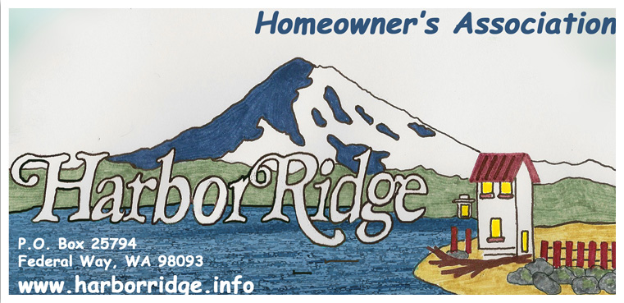

**The 2015 Annual Meeting will be Sunday, January 18, 2015 at 2 p.m.**

**At Resurrection Lutheran Church, 4301 Browns Pt. Blvd.**

**All Harbor Ridge homeowners are invited to participate.**

**This Newsletter serves as the announcement for the meeting.**

**AGENDA: - INTRODUCTIONS**

**- RE-CAP OF 2014**

**- PLANS FOR 2015**

**- ELECTION OF BOARD**

**DUES FOR 2015** – Please bring your $35 annual dues payment to the annual meeting, or mail to:

**Harbor Ridge Homeowners Association**

**P.O. Box 25794**

**Federal Way WA 98093 – 2794**

**“BE GREEN” OPTION:** Members can provide us with their email addresses if they would like to have the periodic Newsletters sent to them by email, rather than mailed or delivered to their doorstep. This saves us printing and mailing costs as well. We have a small list right now but would love to email to many more. Please visit the website ([www.harborridge.info/](http://www.harborridge.info/)) and send us an email.

Fall storms are over but winter storms are on the horizon. We’ve already witnessed torrential rains, near hurricane winds, and cold weather complete with snow and ice. It may be too late but remember to disconnect hoses from outside faucets, (hose bibs), and insulate them. Thawing pipes that burst under your house are no fun to deal with! A good winter tip is: set your thermostat at fifty-five degrees while you are away this winter and many problems caused by freezing weather will be avoided.

Our resident coyote or perhaps coyotes are becoming urbanized and bold. They wander our neighborhood in broad daylight and do not seem overly afraid of humans. Several of us witnessed one openly glaring at a small dog being walked on a leash. If your pets spend time outdoors make sure your fences are intact.

Our community property defining the entrances to our neighborhood were trimmed and cleared. We hired a professional landscaper to do the work. Landscaping costs are significant. If anyone is interested in volunteering time and energy to maintain common areas please contact any Harbor Ridge Association, (HOA), board member. Board member names, phone numbers, and email addresses are listed on our web site.

Several CC&R, (Conditions, covenants and restrictions), infraction notices were sent out throughout the summer. The prompt remedy of those violations is sincerely appreciated by all members of the Harbor Ridge community.

The small, ANNUAL, thirty-five dollar fee to support your HOA is money well spent. Real estate agents will tell you that properties within a community that supports an active homeowners association command a significant premium. CC&Rs monitored by your HOA are in place to maintain the integrity and desirability of your property. Small, routine violations are to be expected and are mostly ignored if they are remedied within a reasonable amount of time. Flagrant violations, ones which require remedial action by the Harbor Ridge Association, (HOA), are few and far between. The main thrust of enforcement is to ensure the broken-window-theory does not take hold in our neighborhood. To summarize, the theory states that ignoring some infractions will lead to other more significant violations. Eventually no violations can be remedied through code enforcement.

**For detailed information on Fighting Crime at Home**: www.cityoftacoma.org/cro/FightCrimeathomebrochure.pdf

**For City of Tacoma Resource guide:** www.cityoftacoma.org/NeighborhoodCouncils/NCResourceGuideWEB.pdf

**For Safe and Clean Brochure:**

www.cityoftacoma.org/cityclerk/files/safeandclean/currentbrochure/5.2010.pdf

**For the NE Tacoma monthly publication, the NET News:**

* receive it in your e-mail by sending a note to [netnews98422@hotmail.com](mailto:netnews98422@hotmail.com), with ‘subscribe’ in the subject line, or
* regularly pick up a paper copy at any of these locations: Center at Norpoint, Kobetich Library, the Howards Corner and the Crescent Heights grocery stores, the TPD substation, North Shore Thai and the North Shore Cleaners (near Walgreens), the Cleaners by the QFC, and at Browns Point (the Diner, the Cleaners, and ACE hardware)

**Tacoma Police / Fire / Medical:**

Emergency – crime/threat in progress, fire, medical: 911

Police Non-Emergency – report crimes and suspicious behavior (wait for pickup): 798-4721 or 2

**To report** **debris, junk vehicles and other nuisances:** call Tacoma Cares at 253-591-5001.

**WEBSITE:** Please visit our website at [www.harborridge.info/](http://www.harborridge.info/). What will you find there? The Harbor Ridge By-Laws, Covenants, Conditions and Restrictions (CC&R’s), board members names and phone numbers, the Board’s meeting dates and much more. For example, check out Article IV, Section 7 and 18:

Section 7. All lots, whether improved or not, shall be fully maintained, including the control of any vegetation.

Section 18. Except with the approval of the ACC, no owner shall at any time keep or allow to be kept on their premises any commercial vehicle, house trailer, truck, camper, mobile home or boat trailer unless housed within a garage or suitably screen from view from any street or lot. For purposes of this provision, a vehicle will be deemed to be stored or kept if parked in driveways or streets for a period of longer than twenty-four (24) hours in any seventy-two (72) hour period.

**NEIGHBORHOOD AWARENESS:** At varying times, there are homes in our area that are vacated, for sale, or in foreclosure. Please be particularly aware of homes that are vacated, both for your sake as a neighbor, and in the interest of the owner. If you notice anything unusual, please report it to the owner, and possibly to the police.